- Shop decoration
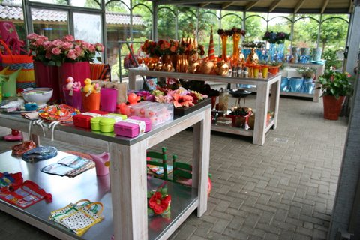

Treat the customer like you would a member of your own family
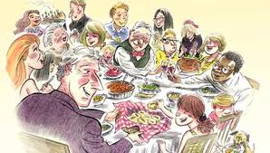
- Watch the film
Decorate your shopping bag
Answer the next questions.(Dutch)
- What stuff the shopping bag is made of?
- How soft are the pencils?
- Why do you need tracing paper?
- What kind of paint she uses?
- What does she use the tissue for?
- Why does she need the card board?
- How long has the paint to be dried?
- Why does she use the brush first en later on the nozzle?
- Before ironing you have to wait a long time; how many hours?
- How short must last the ironing?

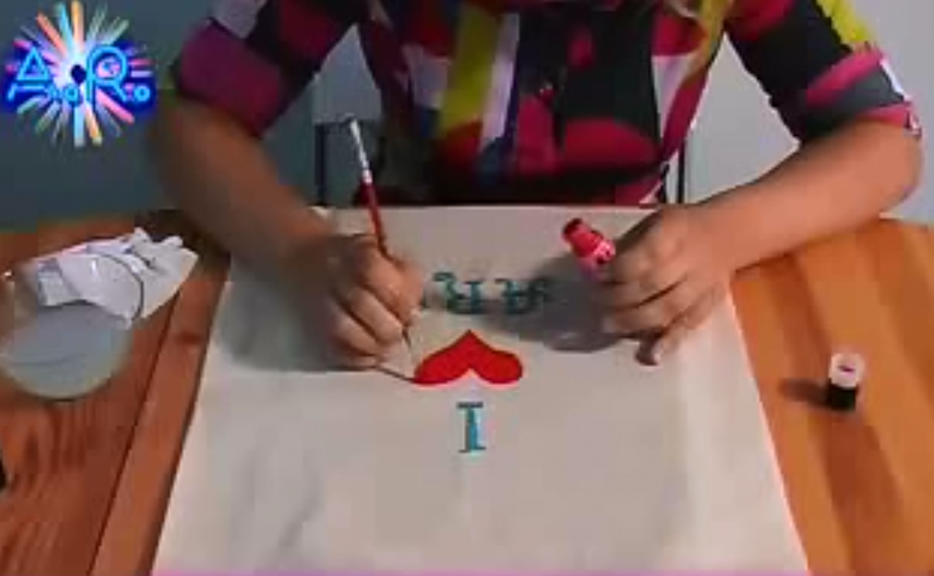
- Match the pictures and words
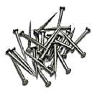 |  | 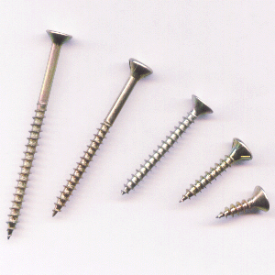 | 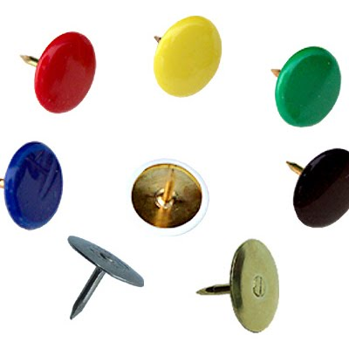
A | B | C | D
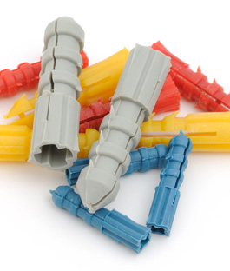 | 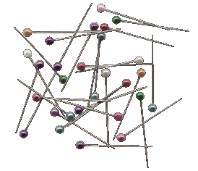 | 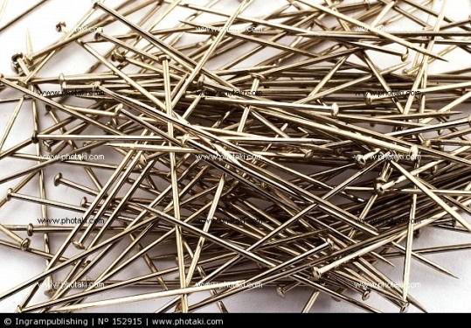 | 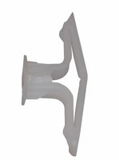
E | F | G | H
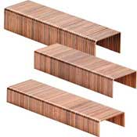 | 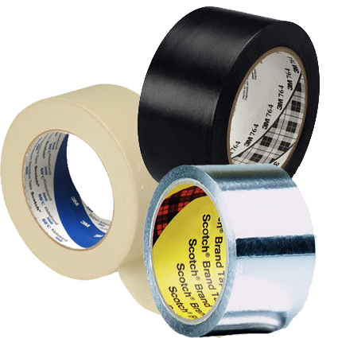 | 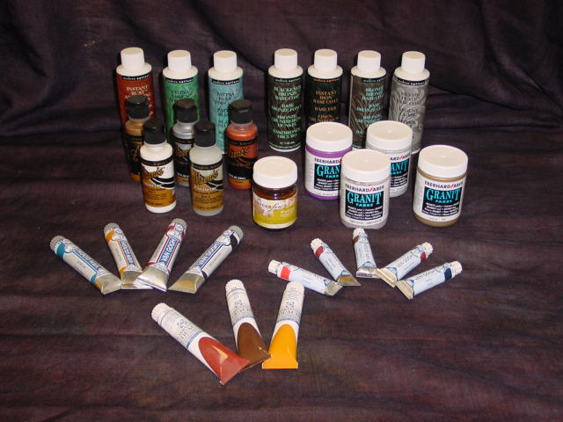 | 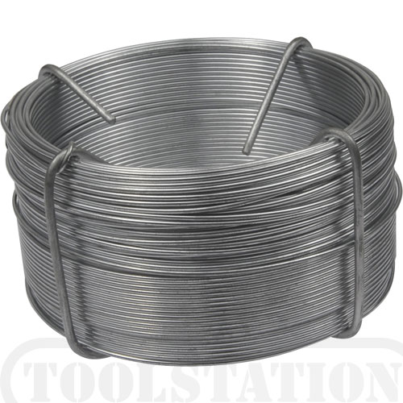
I | J | K | L
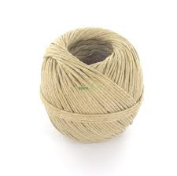 | 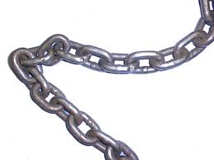 | 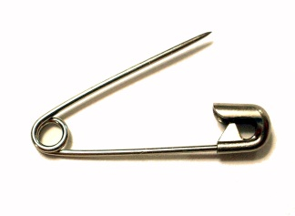 | 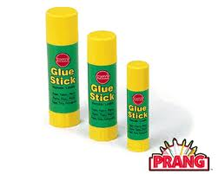
M | N | O | P
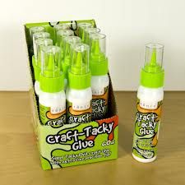 | 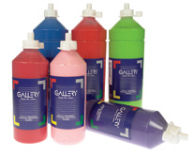 |  | 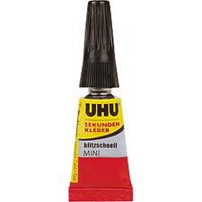
Q | R | S | T

Put the right letter in the right place
 | (straight) pins |  | waterverf
 | acrylic paint |  | veiligheidsspeld
 | button pins |  | touw
 | chain |  | superlijmlijm
 | crafting glue |  | spijkers
 | drawing pin |  | schroeven
 | glue stick |  | punaise (dik)
 | gouache |  | punaise
 | nails |  | pluggen
 | plaster plugs |  | plakkaatverf
 | plugs |  | plakband
 | push pin |  | nietjes
 | rope |  | lijmstift
 | safety pin |  | knutsellijm
 | screws |  | knopspelden
 | staples |  | ketting
 | super glue |  | ijzerdraad
 | tape |  | gipspluggen
 | water colour |  | acrylaatverf
 | wire |  | (kop)spelden

3. Dress For Success – Decorating Your Store To Sell
For this post I invited my wife, Trixy Eichler, to share her design experience with us. She has been in charge of merchandising for various large and small retail stores, including Williams Sonoma, Display and Costume, Storables, and lately at Einmaleins. She has the eye and experience. Currently, she keeps a design blog atTrixwithay.com.

What’s your overall approach and philosophy when decorating retail stores?
TE: Every store has a look and feel that goes beyond the logo and branding. Especially in a retail store your windows and the displays that tell your story and sell your products.
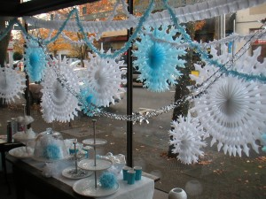
Merchandising your product creatively is part of your marketing strategy. Choosing creative display elements and window decoration gives you a great way to separate your business from the competition down the street. And it doesn’t have to break the bank.
When considering decorating your store, don’t limit yourself by the product in your store. Take inspiration from your surroundings, your community, what might be going on in the world. This will show your customers you’re active, aware, and participate in daily life. You are not just a sales outlet. You give people something to relate to and you’re engaging your customers.

Okay, let’s start with the windows and work ourselves from the outside in.
TE: Of course, when it comes to presenting your products it all starts with your shop windows. Each store layout and windows are different, but some basic rules can be applied to most circumstances.
Let’s take a look at ’Anthropologie’ for example: They put a lot of effort in making their windows creative and tell the outside world what the store feel like. Product is secondary in the windows. Communicating atmosphere and creating a personality is the main focus.
Be aware that product can fade their colours if the sun hits the windows. And remember that the product in your window are part of the inventory. So make sure this is accounted for.
It can be worth investing in some nicer decor pieces for your windows that you can bring back every year and use over again.
What about the displays?
TE: Seasonal displays are important. People shop the so-called “Hallmark holidays”, but that doesn’t mean you have to spend a lot of money on props. Take the ‘dreaded’ Valentines Day for example. Even if you’re not a gift shop, you can easily find red, pink purple coloured products in the store and put them together on a display. That alone will bring attention to it during the right season.
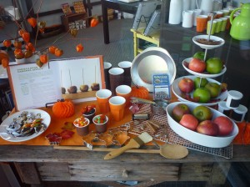
Always try to make your displays shoppable. Customers need to feel comfortable taking a product off the display for purchase.
Feature product by repeating it in your displays, but just make sure it doesn’t have the ‘Costco-look’.

What were some of the things you did at Einmaleins?
TE: We had big wrap-around windows. It was impossible to change things out as often as we would’ve liked. So we worked on big elaborate seasonal displays. For example for one summer I cut wax paper discs in bright colours, and created stripes of rainbow colours. This takes time, and you have to plan ahead. But it’s worth it and the discs were reused in a different style for different occasions.
One year we hung big branches, with leaves cut out of newspaper. We had a special wiring in the window frame that allowed us to hang various items without always needing to drill new holes.
Another big focus each year was finding Holiday decoration that we could use throughout Winter. We didn’t want to have to change over displays during the busy season between Christmas and News Years. So instead of focusing on Santas we used stars and snowflakes that still worked well in January.

Where do you find inspiration for your decoration?
TE: I like going back to childhood and think of some of the projects we did as children. I make them bigger and more sophisticated. But often I am able to use the same simple materials and techniques, often with stunning results.

Who could help out if you feel like you’re the uncreative type?
TE: Ask your staff to help you, but be sure to set standards for how much time can be spent on decorating and resetting displays. Or a family-member might find an outlet by taking on the creative lead in your store.

Finally, what are some ideas for sourcing products?
TE: Display props: the Dollar store can have great finds for baskets, inexpensive props, and seasonal items. Craft stores will offer fabrics, paper, and other supplies. Second hand stores can also be helpful for finding funky add-ons for seasonal displays.

Thanks for your time.
TE: You’re welcome and thanks for having me.

accounted for | rekening mee gehouden | occasions | gelegenheden
applied | toegepast | outlet | uitlaat
approach | benadering, aanpak | pieces | stukken
aware | bewust | props | attributen
beyond | verder, buiten | props | rekwisieten, attributen, spullen
branding | merken voeren | retail | wederverkoop, detailhandel
circumstances | omstandigheden | sales outlet | verkooppunt
community | gemeenschap | seasonal | seizoengebonden
competition | concurrentie | separate | apart
considering | beschouwen | separate | gescheiden, apart
Costco-look | Costco-look | shoppable | shoppable
craft store | handenarbeidzaak | store | winkel
displays | displays | stunning | prachtig
displays | displays, uitstalling | surroundings | omgeving
dreaded | gevreesd | to break the bank | de kop kosten
effort | poging, moeite | to elaborate | uitwerken
einmaleins | basics | to fade | vervagen
focus | brandpunt | to limit | begrenzen
funky | hippe | to participate | meedoen
inventory | inventaris | wax paper | vetvrij papier
merchandising | merchandising | window | etalage
merchandising | verhandelen | wrap around | wikkelen

Answer the next questions.(Dutch)
  - Who is interviewed?
  - What is it that the title suggest?
  - How can you be ahead of your competitors?
  - What can de sun do to your window props?
  - Why is ‘dreaded’ between quotation marks?
  - How would define ‘shoppable’?
  - What do you think is Costco-look?
  - Why does she suggest not to use Santas with Christmas?
  - Where did she find inspiration?
  - At what places is she looking for inexpensive props?

I | N | T | E | L | L | I | G | E | N | C | E
D | I | V | E | R | S | E | T | O | O | O | D
E | E | E | V | I | T | A | I | T | I | N | I
A | V | G | R | O | W | T | H | O | T | T | W
F | U | N | Y | D | A | E | T | S | N | R | T
E | S | A | C | C | E | S | S | N | E | O | H
G | E | R | O | D | E | E | E | U | T | L | G
A | F | L | U | N | C | H | U | G | T | R | I
S | U | N | B | O | N | E | L | B | A | T | S
S | L | Y | R | A | D | I | U | S | T | M | N
E | X | P | E | C | T | A | T | I | O | N | I
M | A | J | O | R | E | C | U | D | O | R | P
search in all directions

INTELLIGENCE | DIVERSE | VEIN
MESSAGE | DO | PRODUCE
FUN | MAJOR | INSIGHT
RADIUS | GROWTH | USEFUL
BONE | BATS | TOO
LUNCH | TRI | TOE
SNUG | EVERY | ERODE
TABLE | CONTROL | GUNS
STABLE | PROCESS | HOT
HIT | RANGE | STEADY
ACCESS | ATTENTION | SUN
EXPECTATION | IDEA

Which word in the puzzle is not in the list? Write it down below!

